Re-analysis of the SER data from the included systematic reviews and meta-analyses.

**Yanyan Song et al. (2011)**

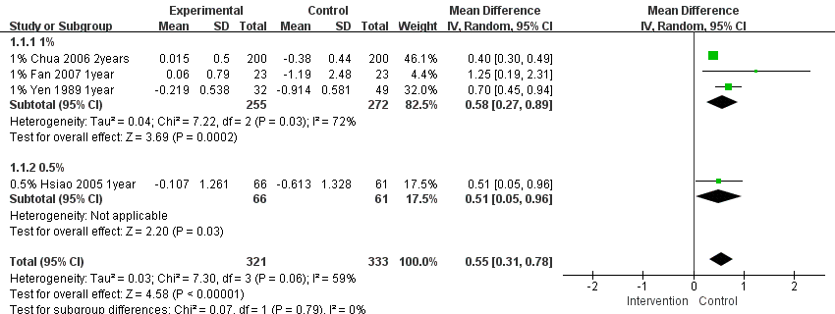

**Shiming Li et al. (2014)**

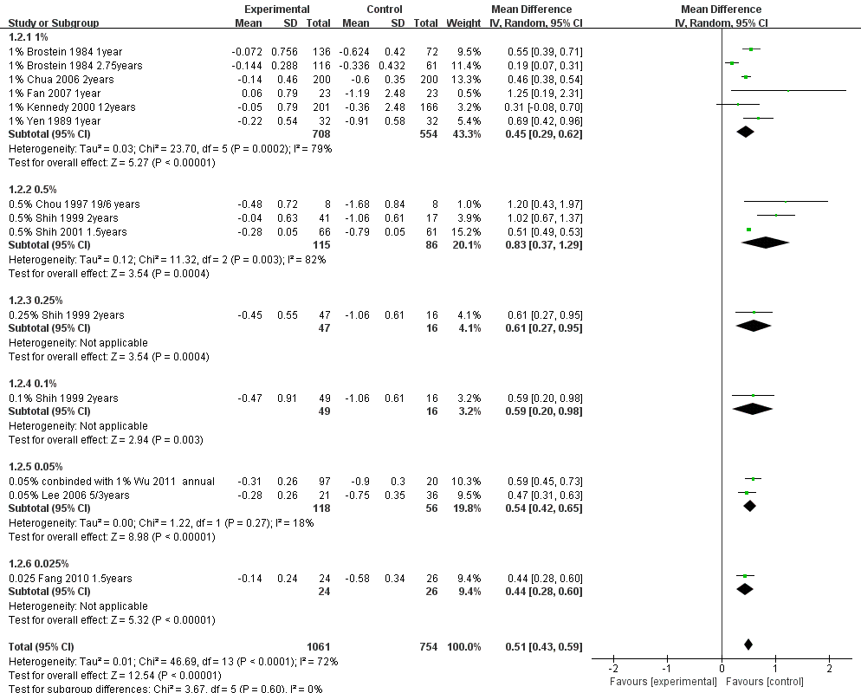

**Chunwen Chen et al. (2021)**

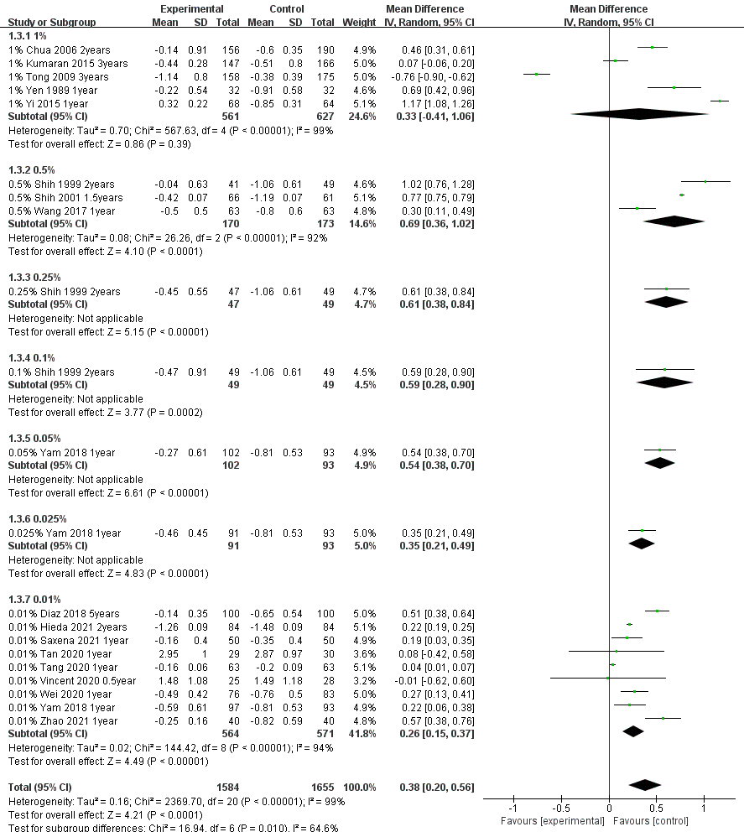

**Jiahe Gan et al. (2022)**

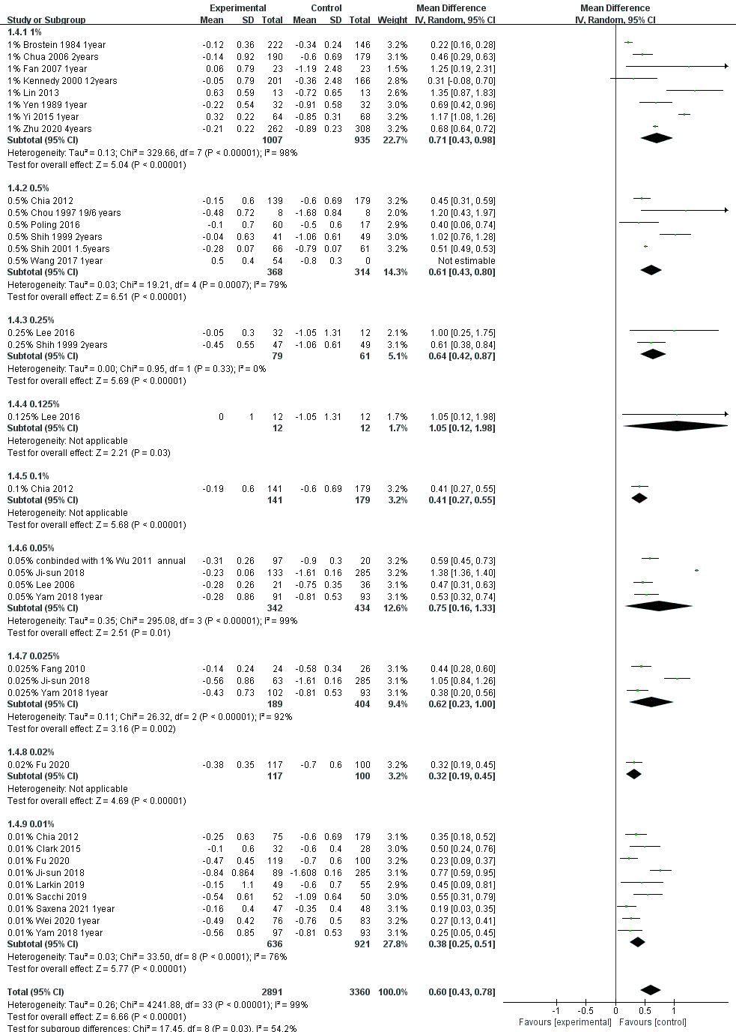

**Qianwen Gong et al. (2017)**

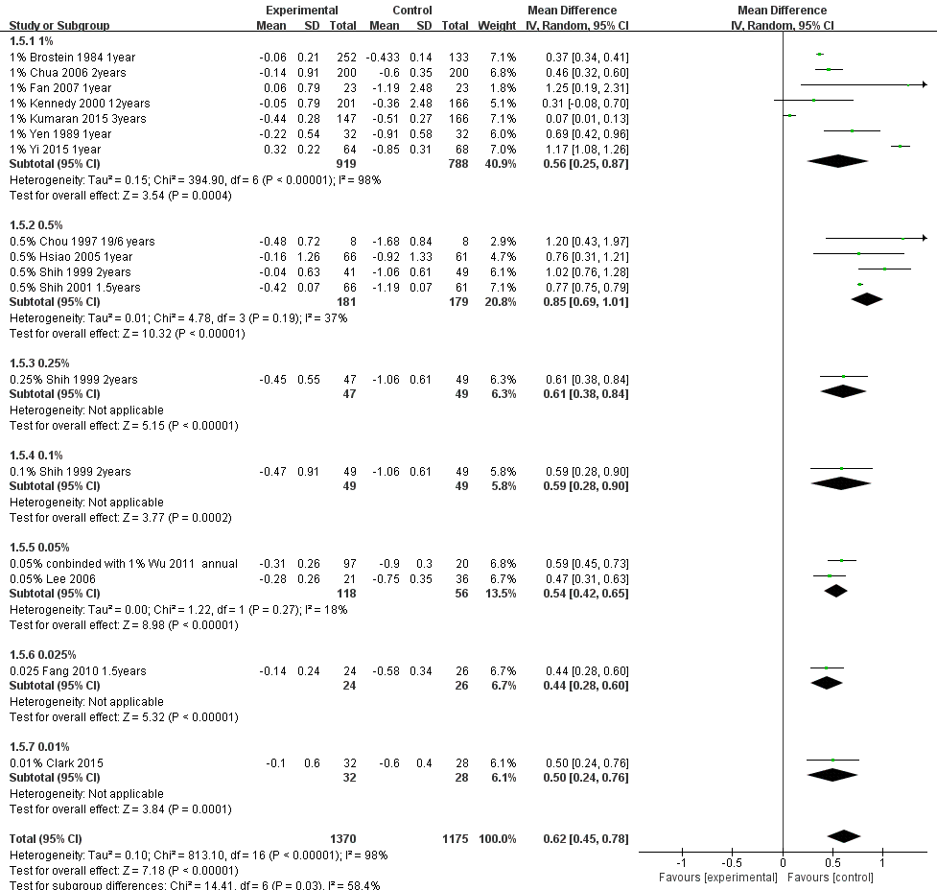

**Carla Lanca et al. (2023)**

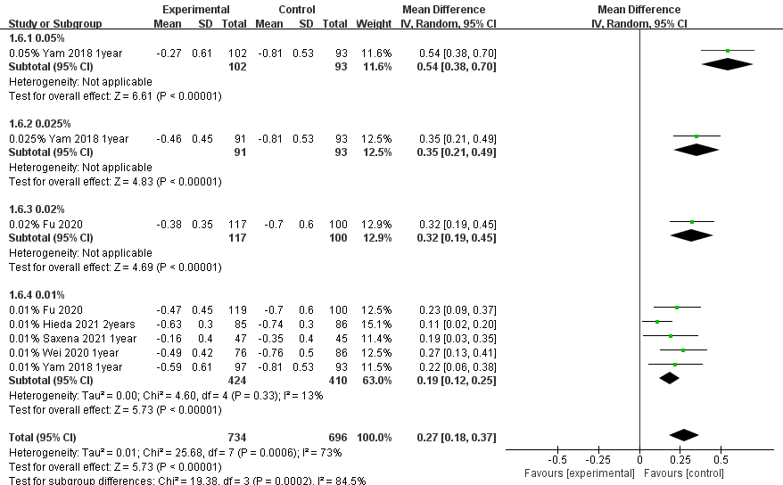

**Huy D M Tran et al. (2021)**

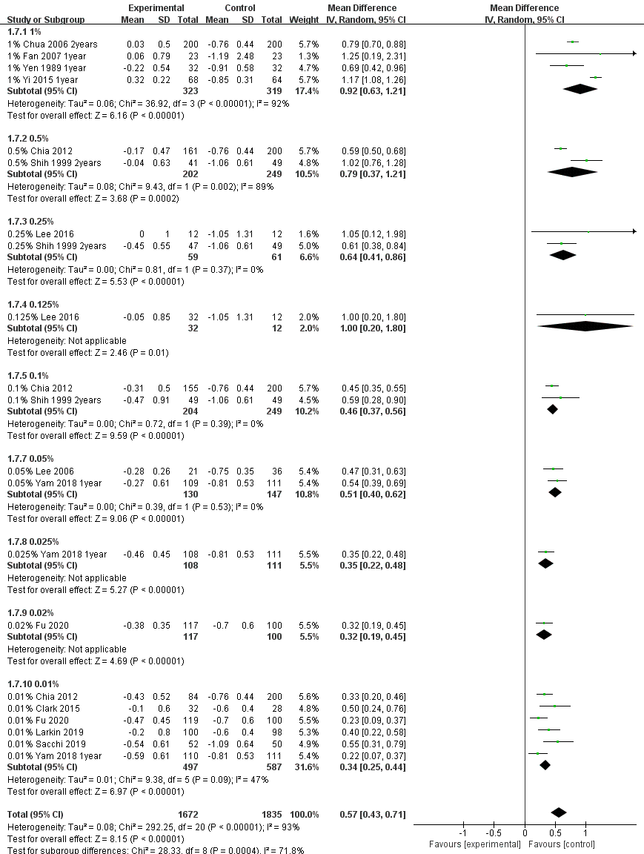

**Congling Zhao et al. (2020)**

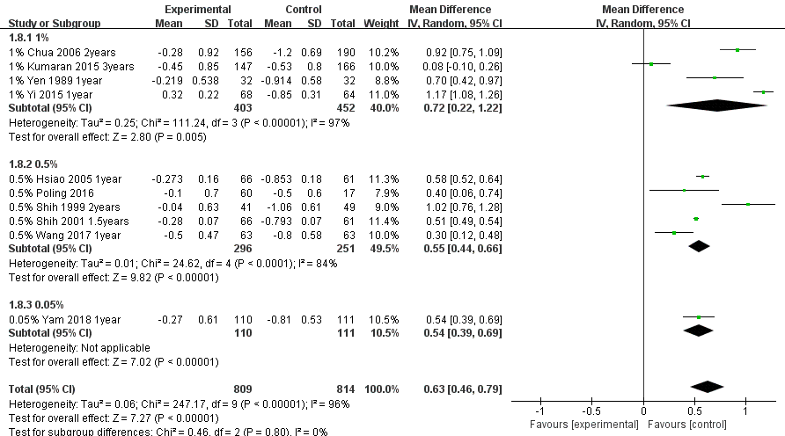

**Ningning Zheng et al. (2022)**

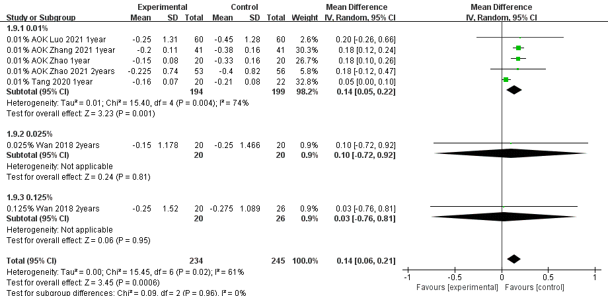

**Xinli Wei et al. (2023) (Figure was downloaded from the research article of Xinli Wei)**

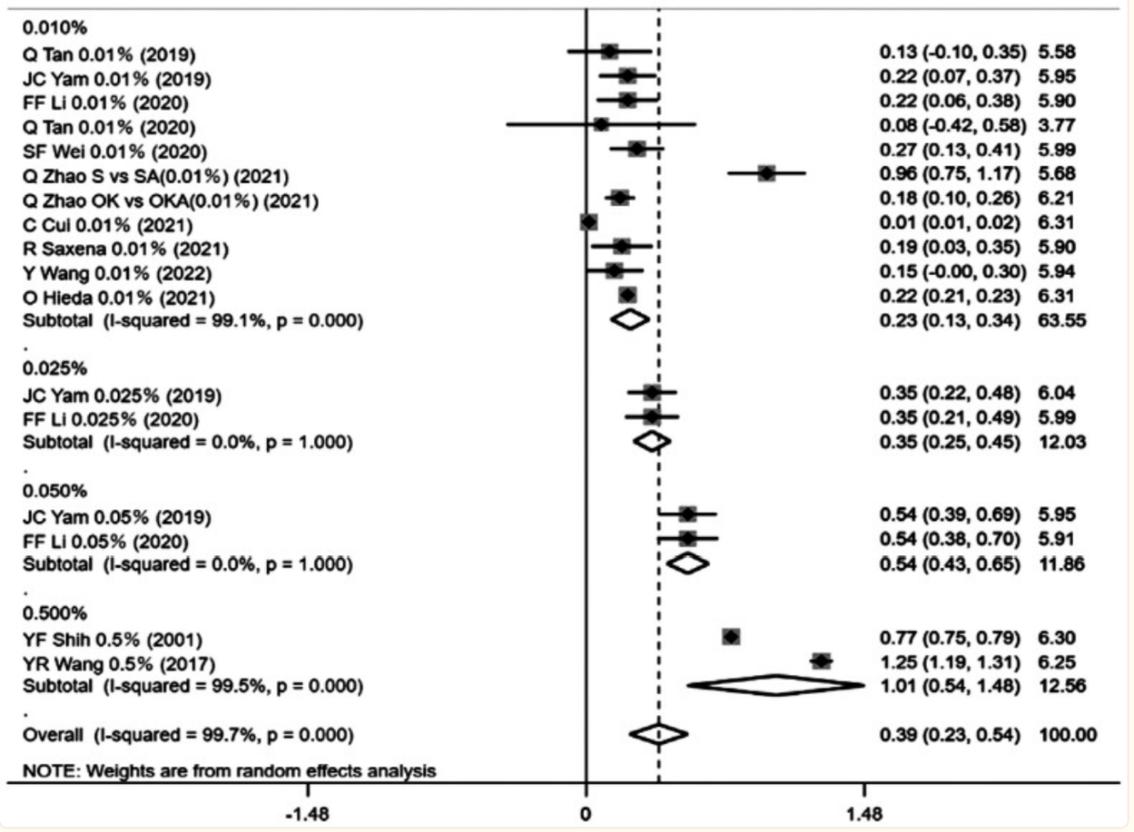

**Houren Tsai et al. (2021)**

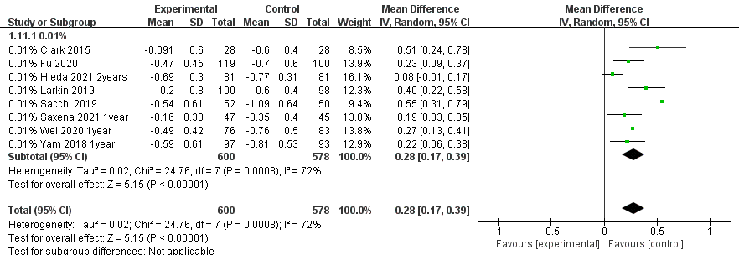

**Weiying Sun et al. (2022)**

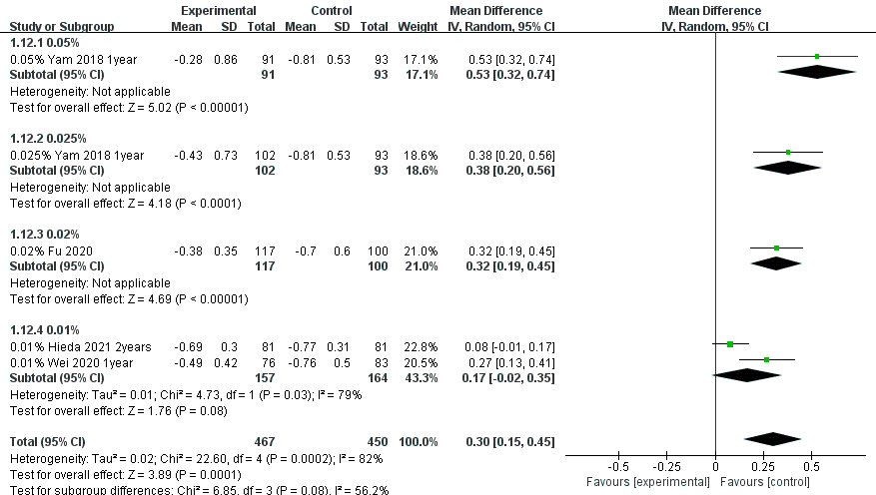

**Haobo Fan et al. (2021)**

